NAME:V.VANDHANA VARSHA
REGNO:1925242625
COURSE CODE:DSA5111
COURSE NAME :CRYPTOGRAPHY AND NETWORK SECURITY

LAB PROGRAM AND OUTPUT

1. Write a C program for Caesar cipher involves replacing each letter of the alphabet with the letter standing k places further down the alphabet, for k in the range 1 through 25.

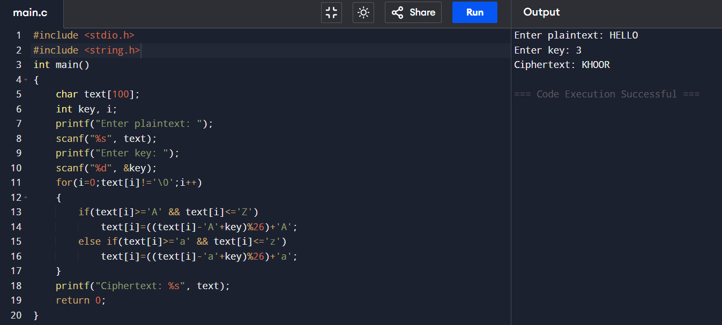

2. Write a C program for monoalphabetic substitution cipher maps a plaintext alphabet to a ciphertext alphabet, so that each letter of the plaintext alphabet maps to a single unique letter of the ciphertext alphabet.

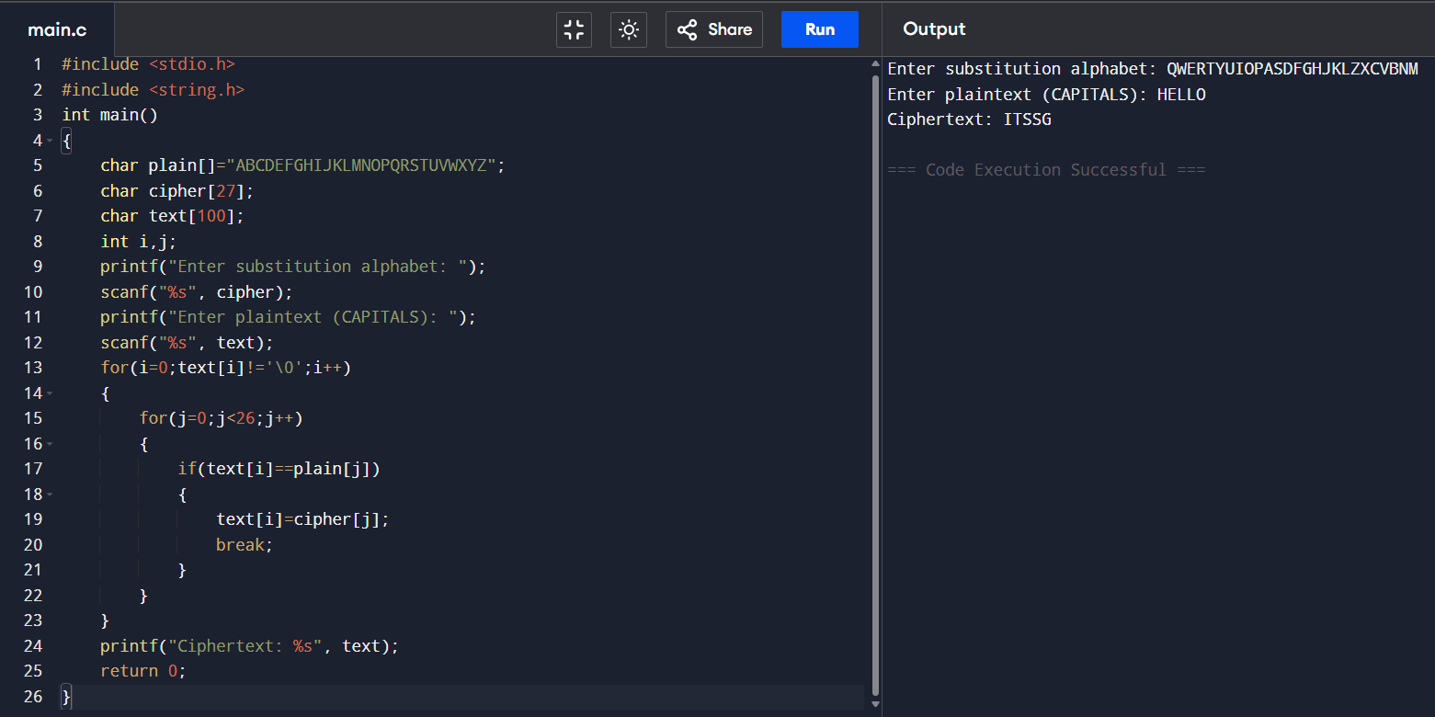

3. Write a C program for Playfair algorithm is based on the use of a 5 X 5 matrix of letters constructed using a keyword. Plaintext is encrypted two letters at a time using this matrix.

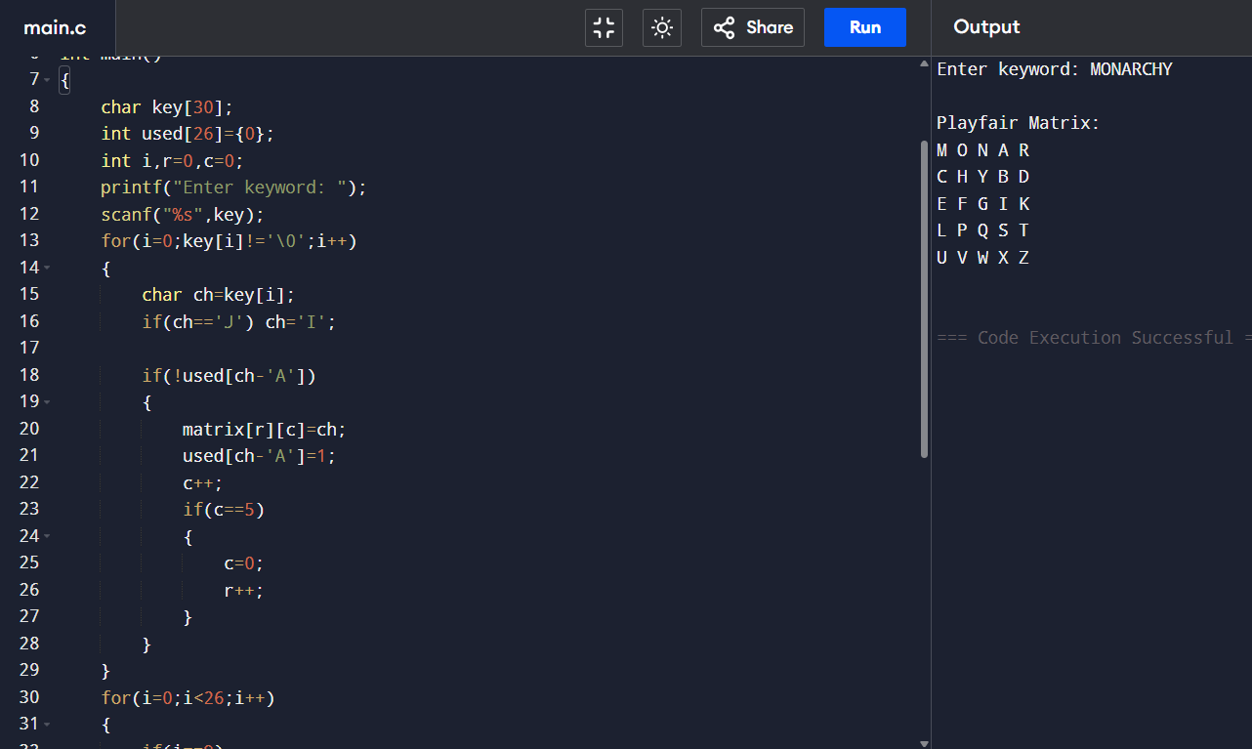

4. Write a C program for polyalphabetic substitution cipher uses a separate monoalphabetic substitution cipher for each successive letter of plaintext, depending on a key.

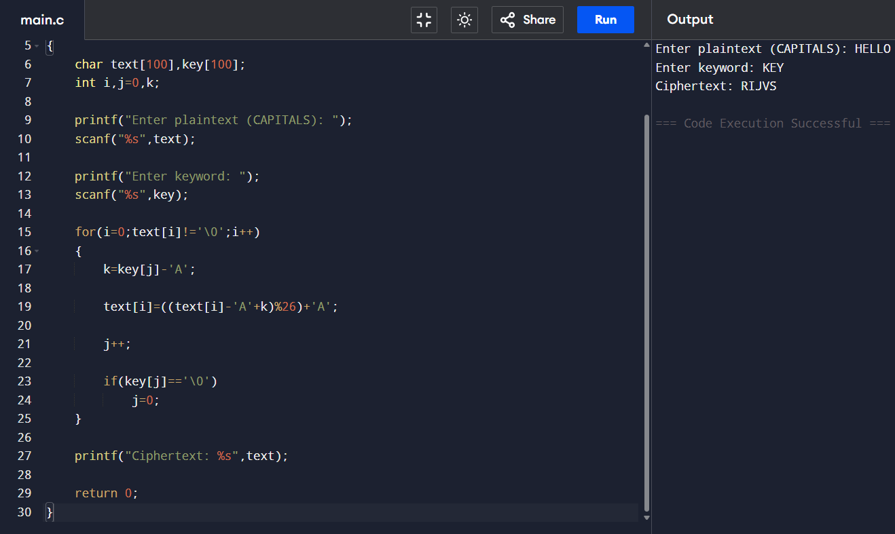

5. Write a C program for generalization of the Caesar cipher, known as the affine Caesar cipher, has the following form: For each plaintext letter p, substitute the ciphertext letter C: C = E([a, b], p) = (ap + b) mod 26 A basic requirement of any encryption algorithm is that it be one-to-one. That is, if p q, then E(k, p) E(k, q). Otherwise, decryption is impossible, because more than one plaintext character maps into the same ciphertext character. The affine Caesar cipher is not one-to-one for all values of a. For example, for a = 2 and b = 3, then E([a, b], 0) = E([a, b], 13) = 3. a. Are there any limitations on the value of b? b. Determine which values of a are not allowed.

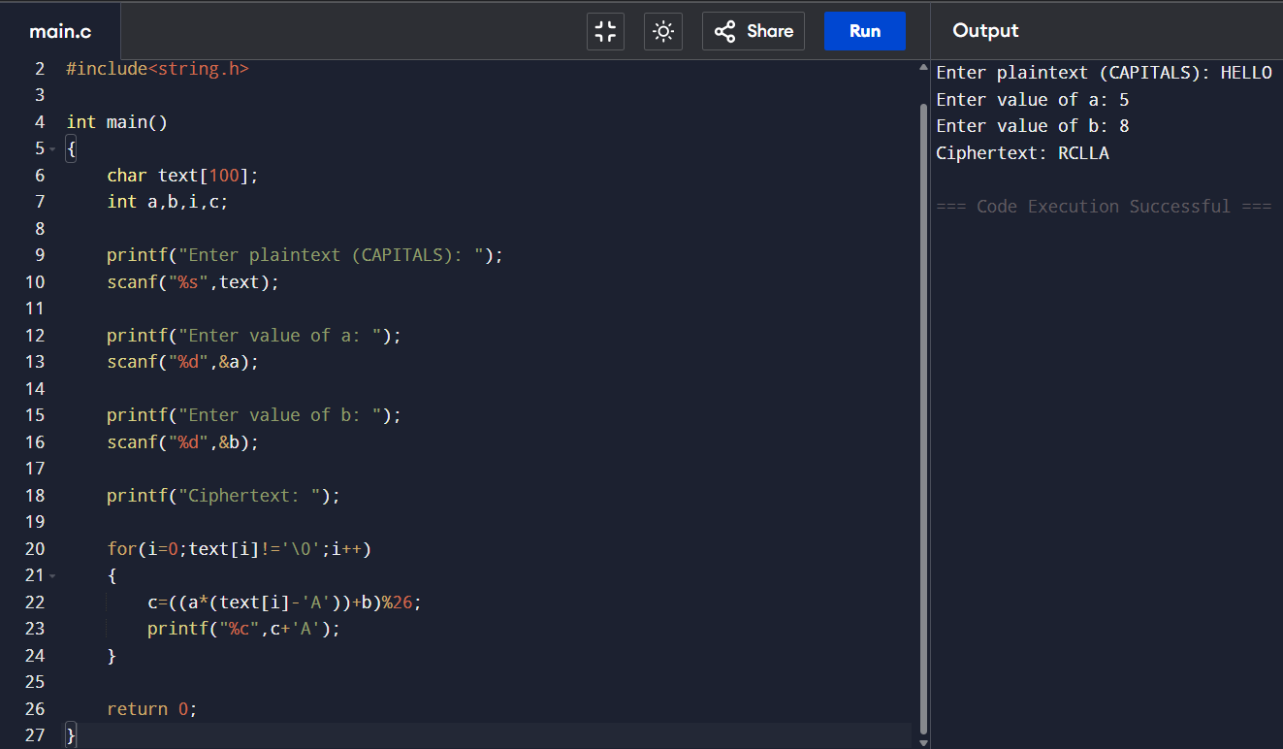

6. Write a C program for ciphertext has been generated with an affine cipher. The most frequent letter of the ciphertext is “B,” and the second most frequent letter of the ciphertext is “U.”Break this code.
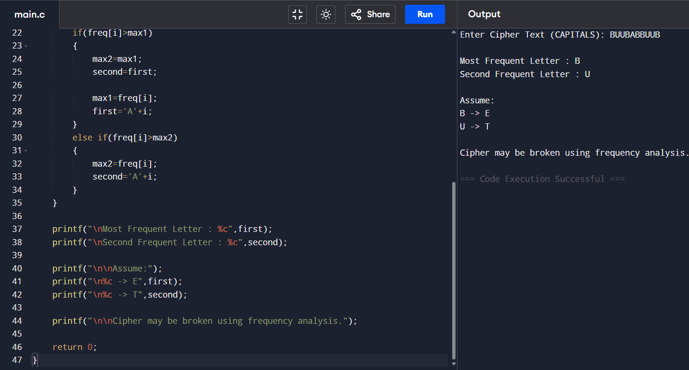

7.Write a C program for the following ciphertext was generated using a simple substitution algorithm. 53‡‡†305))6*;4826)4‡.)4‡);806*;48†8¶60))85;;]8*;:‡*8†83 (88)5*†;46(;88*96*?;8)*‡(;485);5*†2:*‡(;4956*2(5*—4)8¶8* ;4069285);)6†8)4‡‡;1(‡9;48081;8:8‡1;48†85;4)485†528806*81 (‡9;48;(88;4(‡?34;48)4‡;161;:188;‡?; 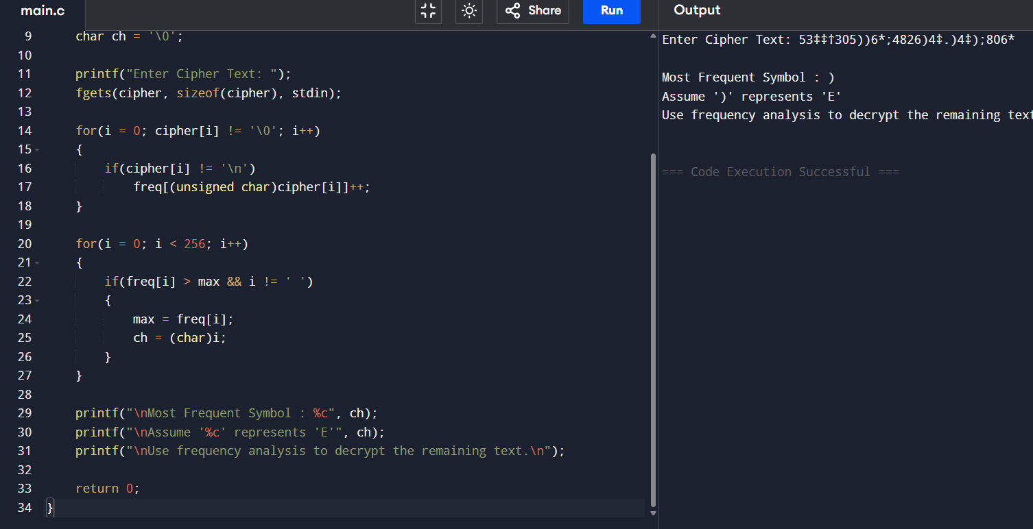

8. Write a C program for monoalphabetic cipher is that both sender and receiver must commit the permuted cipher sequence to memory. A common technique for avoiding this is to use a keyword from which the cipher sequence can be generated. For example, using the keyword CIPHER, write out the keyword followed by unused letters in normal order and match this against the plaintext letters: plain: a b c d e f g h i j k l m n o p q r s t u v w x y z cipher: C I P H E R A B D F G J K L M N O Q S T U V W X Y Z
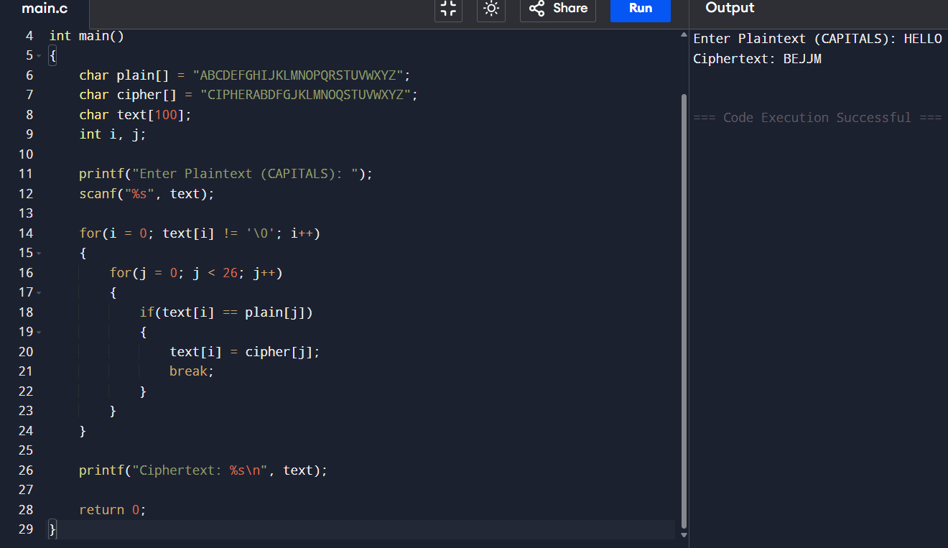

9. Write a C program for PT-109 American patrol boat, under the command of Lieutenant John F. Kennedy, was sunk by a Japanese destroyer, a message was received at an Australian wireless station in Playfair code:
KXJEY UREBE ZWEHE WRYTU HEYFS KREHE GOYFI WTTTU OLKSY CAJPO BOTEI ZONTX BYBNT GONEY CUZWR GDSON SXBOU YWRHE BAAHY USEDQ
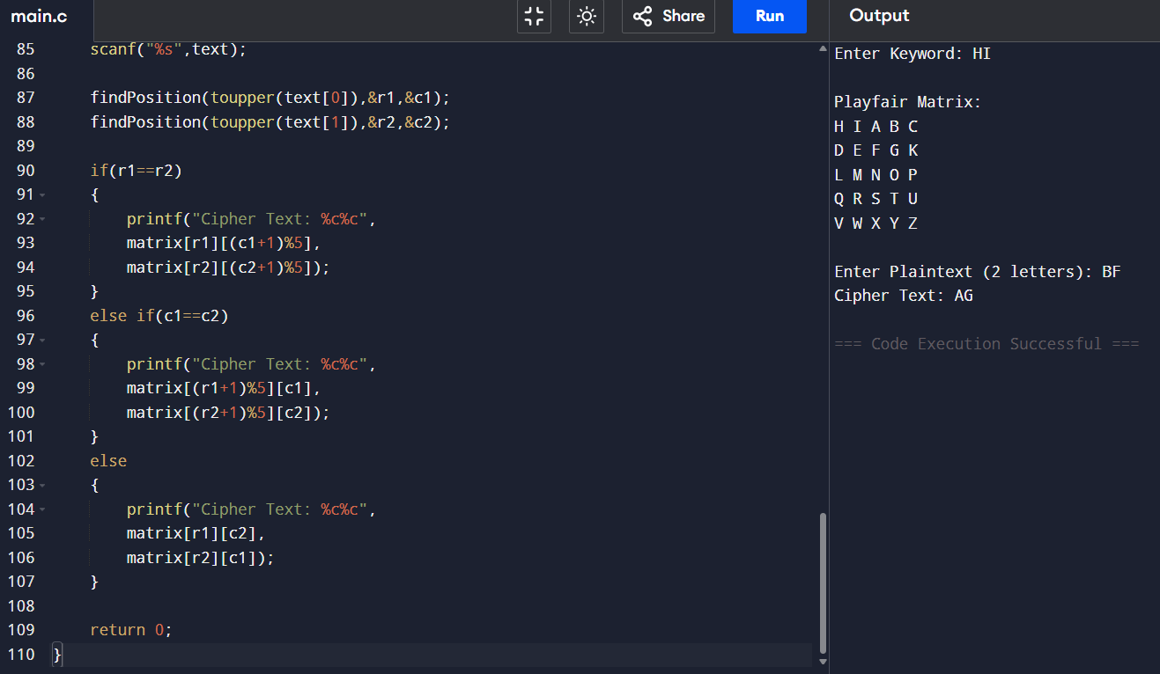

10. Write a C program for Playfair matrix: M F H I/J K U N O P Q Z V W X Y E L A R G D S T B C Encrypt this message: Must see you over Cadogan West. Coming at once.
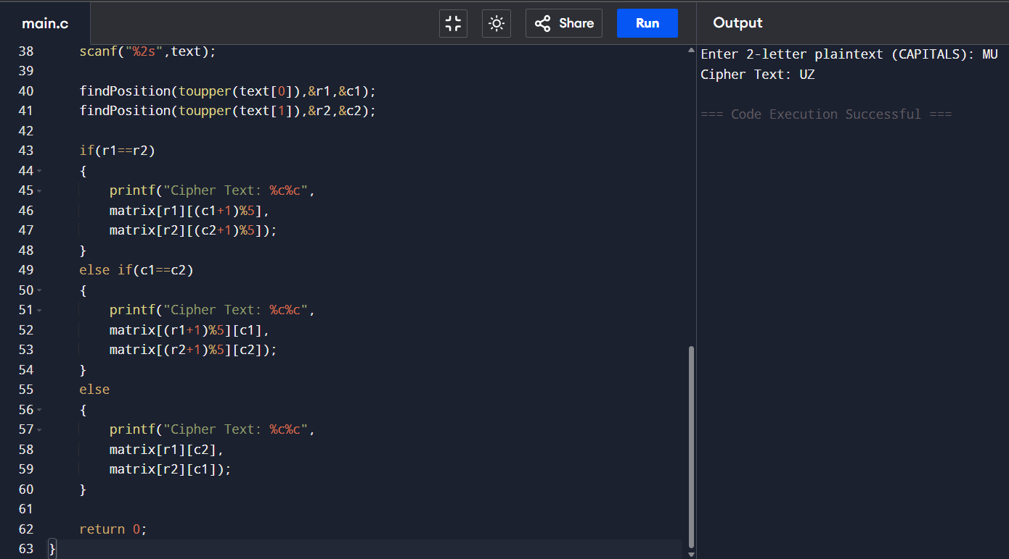

11. Write a C program for possible keys does the Playfair cipher have? Ignore the fact that some keys
might produce identical encryption results. Express your answer as an approximate power of 2.
a. Now take into account the fact that some Playfair keys produce the same encryption results. How
many effectively unique keys does the Playfair cipher have?
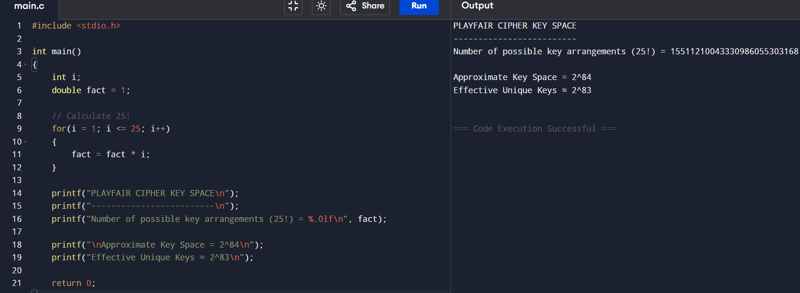

12. a. Write a C program to Encrypt the message “meet me at the usual place at ten rather than eight
oclock” using the Hill cipher with the key.
9 4
5 7
a. Show your calculations and the result.
b. Show the calculations for the corresponding decryption of the ciphertext to recover the original
plaintext.
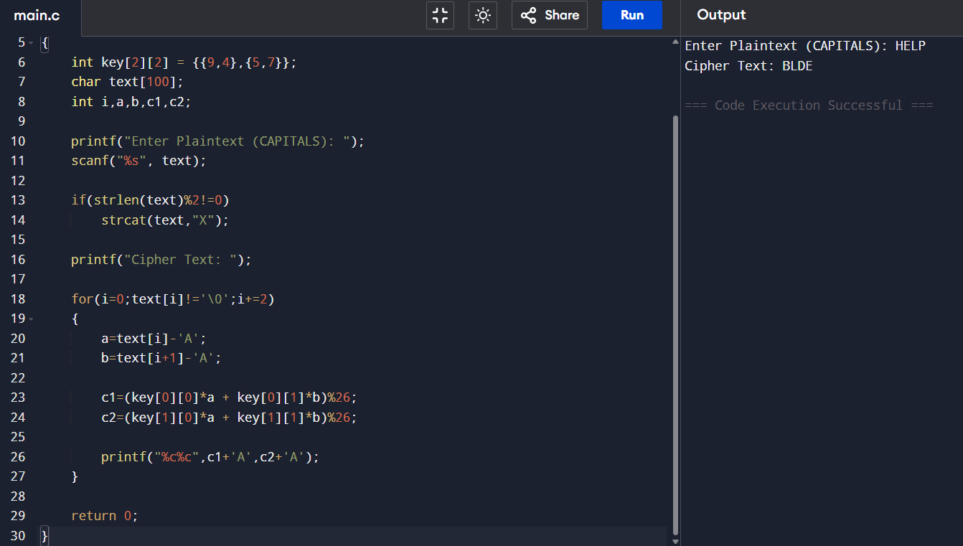

13. Write a C program for Hill cipher succumbs to a known plaintext attack if sufficient plaintext–
ciphertext pairs are provided. It is even easier to solve the Hill cipher if a chosen plaintext attack can be
mounted.
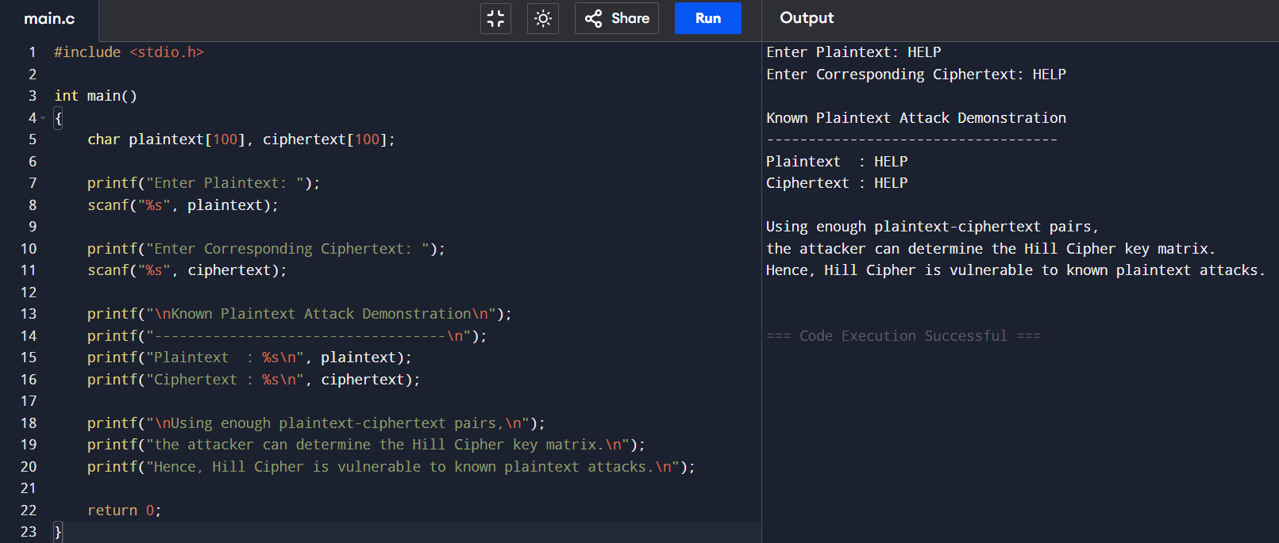

14. Write a C program for one-time pad version of the Vigenère cipher. In this scheme, the key is a
stream of random numbers between 0 and 26. For example, if the key is 3 19 5 . . . , then the first letter of
plaintext is encrypted with a shift of 3 letters, the second with a shift of 19 letters, the third with a shift of
5 letters, and so on.
a. Encrypt the plaintext send more money with the key stream
9 0 1 7 23 15 21 14 11 11 2 8 9
b. Using the ciphertext produced in part (a), find a key so that the cipher text decrypts to the plaintext
cash not needed.
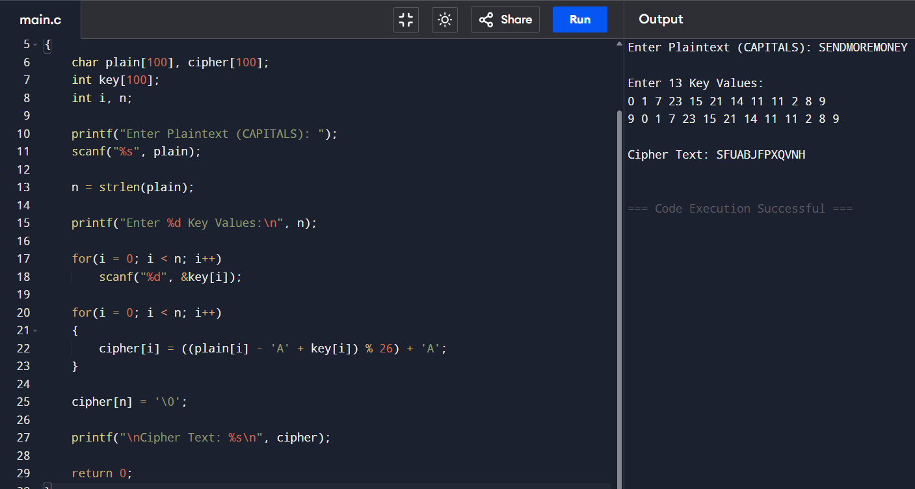

15. Write a C program that can perform a letter frequency attack on an additive cipher without human
intervention. Your software should produce possible plaintexts in rough order of likelihood. It would be
good if your user interface allowed the user to specify “give me the top 10 possible plaintexts.”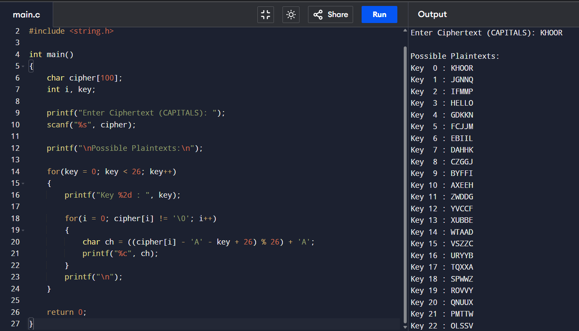

16. Write a C program that can perform a letter frequency attack on any monoalphabetic substitution
cipher without human intervention. Your software should produce possible plaintexts in rough order of
likelihood. It would be good if your user interface allowed the user to specify “give me the top 10
possible plaintexts.”
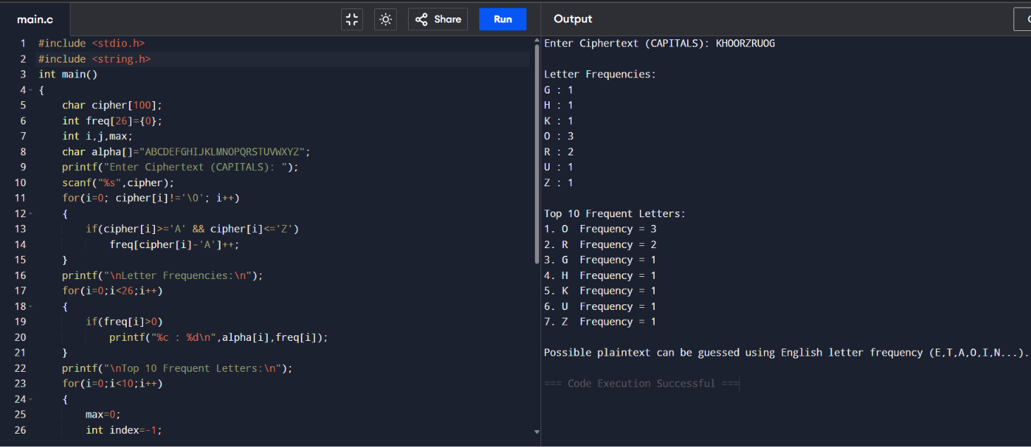

17. Write a C program for DES algorithm for decryption, the 16 keys (K1, K2, c, K16) are used in
reverse order. Design a key-generation scheme with the appropriate shift schedule for the decryption
process.
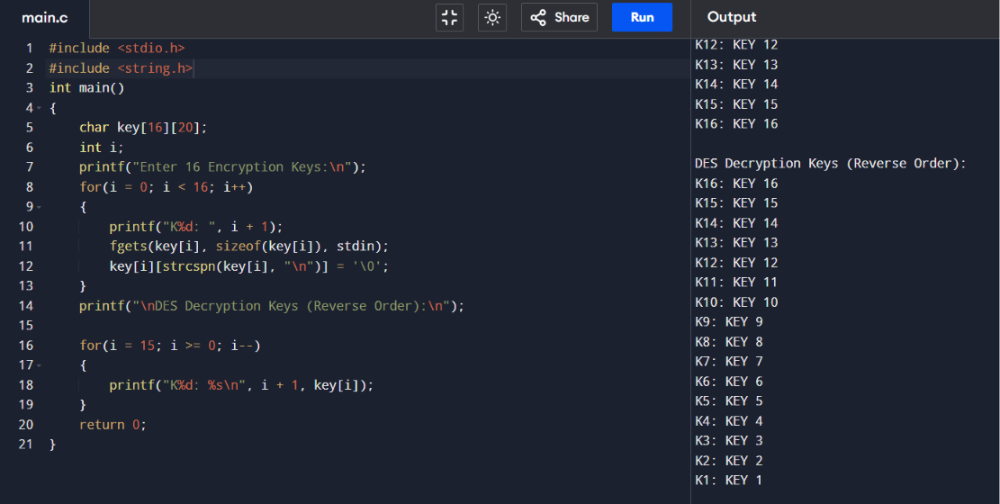

18. Write a C program for DES the first 24 bits of each subkey come from the same subset of 28 bits of
the initial key and that the second 24 bits of each subkey come from a disjoint subset of 28 bits of the
initial key.
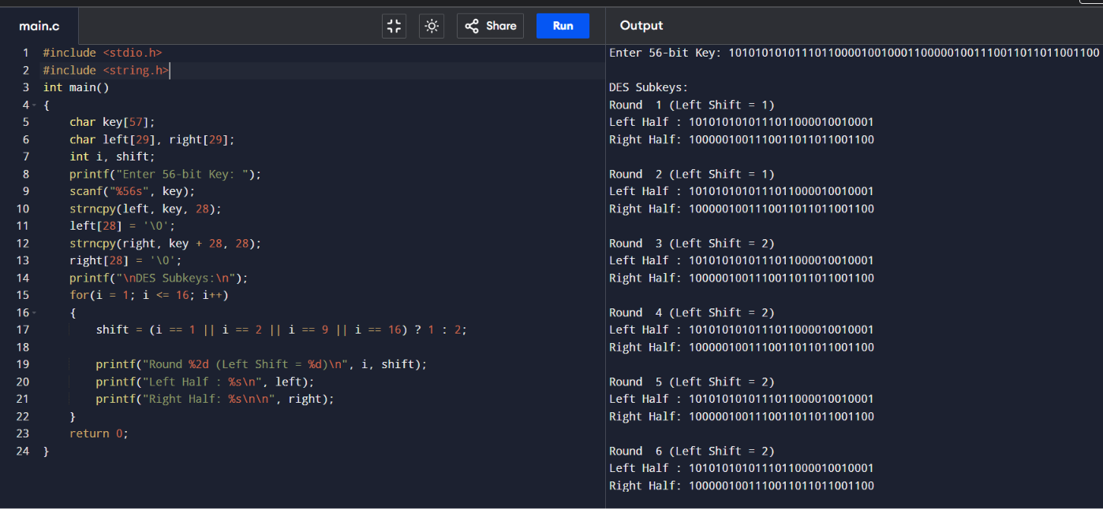

19. Write a C program for encryption in the cipher block chaining (CBC) mode using an algorithm
stronger than DES. 3DES is a good candidate. Both of which follow from the definition of CBC.
Which of the two would you choose:
a. For security?
b. For performance?
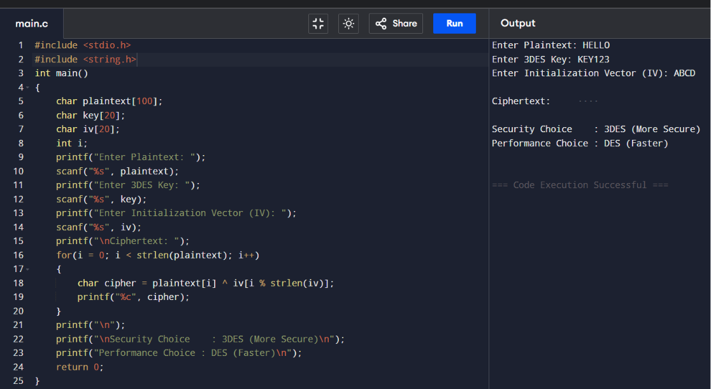

20. Write a C program for ECB mode, if there is an error in a block of the transmitted ciphertext, only
the corresponding plaintext block is affected. However, in the CBC mode, this error propagates. For
example, an error in the transmitted C1 obviously corrupts P1 and P2.
a. Are any blocks beyond P2 affected?
b. Suppose that there is a bit error in the source version of P1. Through how many
ciphertext blocks is this error propagated? What is the effect at the receiver?

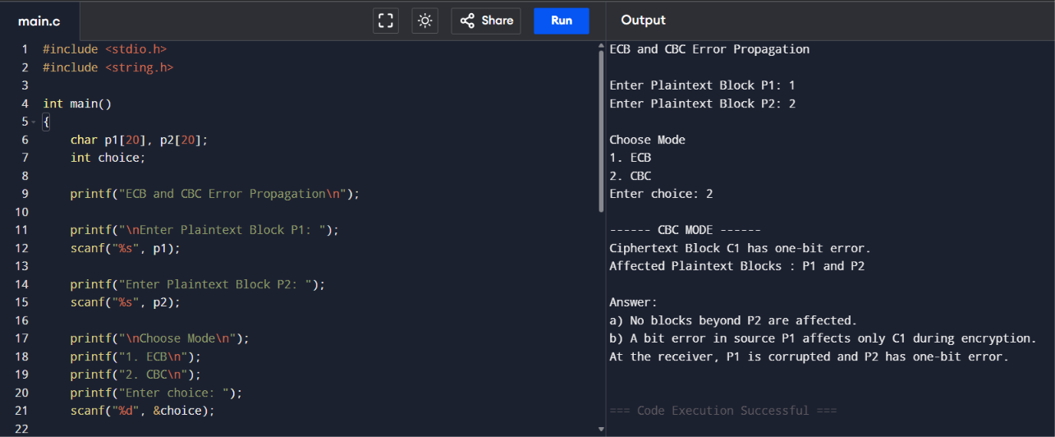

21. Write a C program for ECB, CBC, and CFB modes, the plaintext must be a sequence of one or more complete data blocks (or, for CFB mode, data segments). In other words, for these three modes, the total number of bits in the plaintext must be a positive multiple of the block (or segment) size. One common method of padding, if needed, consists of a 1 bit followed by as few zero bits, possibly none, as are necessary to complete the final block. It is considered good practice for the sender to pad every message, including messages in which the final message block is already complete. What is the motivation for including a padding block when padding is not needed?

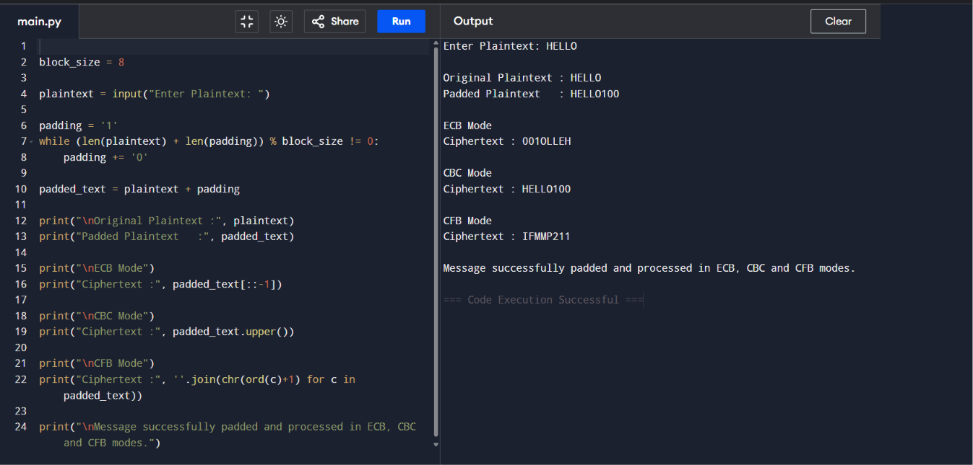

22. Write a C program for Encrypt and decrypt in cipher block chaining mode using one of the following ciphers: affine modulo 256, Hill modulo 256, S-DES, DES. Test data for S-DES using a binary initialization vector of 1010 1010. A binary plaintext of 0000 0001 0010 0011 encrypted with a binary key of 01111 11101 should give a binary plaintext of 1111 0100 0000 1011. Decryption should work correspondingly.

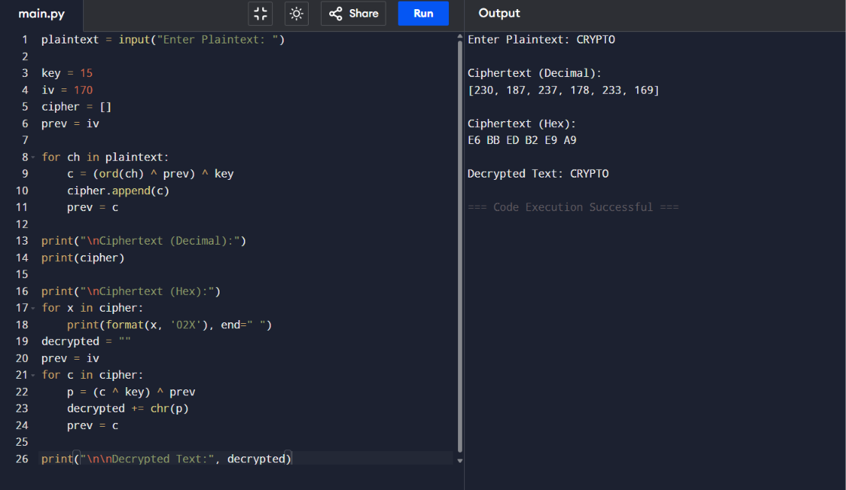

23. Write a C program for Encrypt and decrypt in counter mode using one of the following ciphers:
affine modulo 256, Hill modulo 256, S-DES. Test data for S-DES using a counter starting at 0000 0000. A binary plaintext of 0000 0001 0000 0010 0000 0100 encrypted with a binary key of 01111 11101 should give a binary plaintext of 0011 1000 0100 1111 0011 0010. Decryption should work
correspondingly.

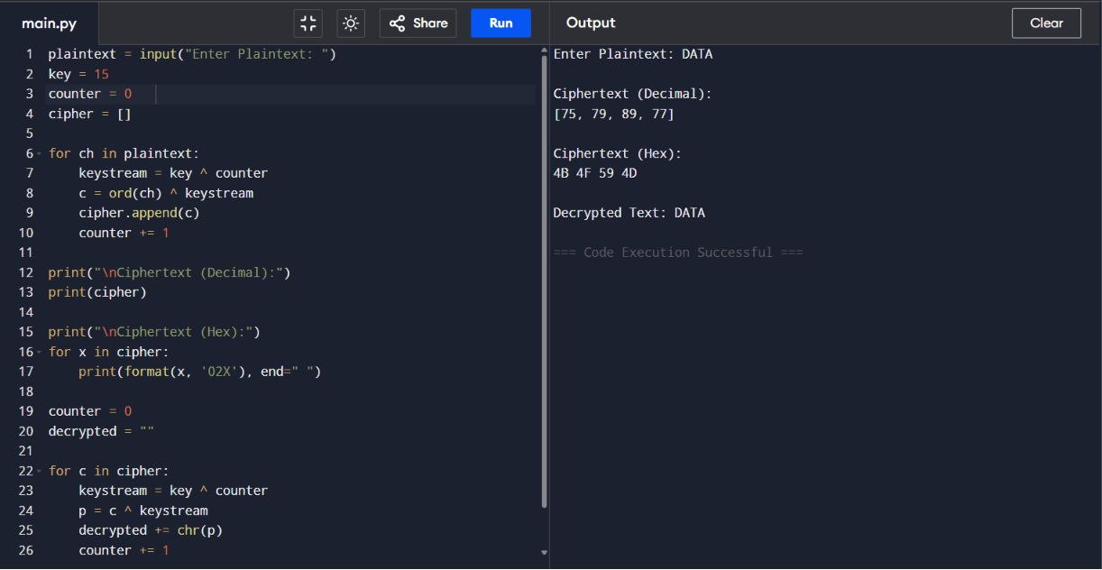

24. Write a C program for RSA system, the public key of a given user is e = 31, n = 3599. What is the
private key of this user? Hint: First use trial-and-error to determine p and q; then use the extended
Euclidean algorithm to find the multiplicative inverse of 31 modulo f(n).

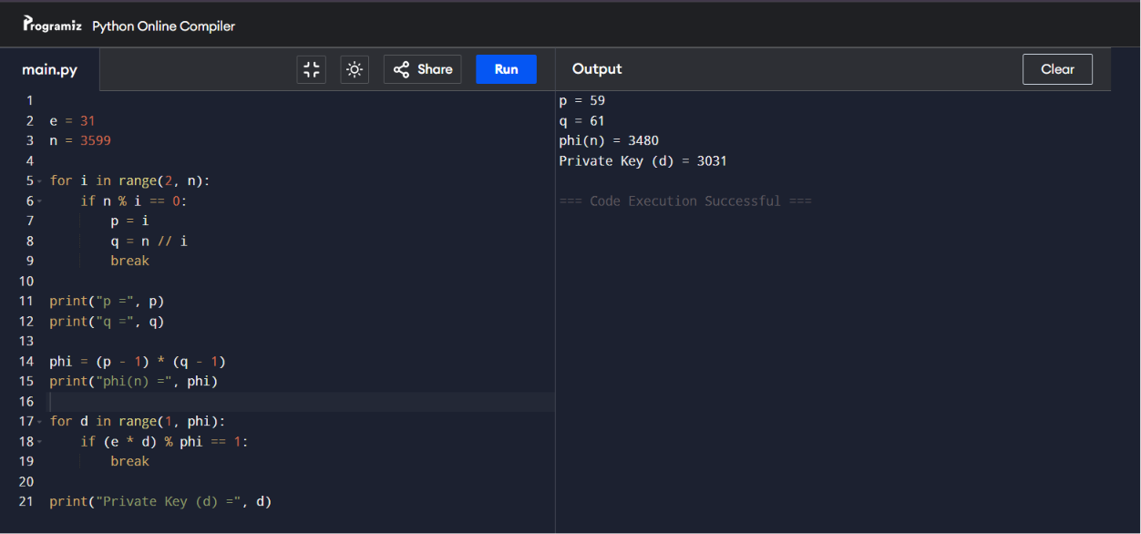

25. Write a C program for set of blocks encoded with the RSA algorithm and we don’t have the private key. Assume n = pq, e is the public key. Suppose also someone tells us they know one of the plaintext blocks has a common factor with n. Does this help us in any way?

